Because of the Data Protection Act 1998, SEA Recruitment Services Ltd will NOT pass your information to anyone else outside the SEA Team other than potential employers.
- Please fill in all sections of this form
- Please type or write clearly in black ink
- Please check through the form before you sign and date it

Are you looking for?  Temporary/Bank work  Permanent work  Will accept temporary or permanent work | If permanent work, what job role are you applying for? (Please state)

PERSONAL DETAILS
Surname
First name(s)
Date of birth |  | Gender: Male Female
Home Address
 | Postcode:
Telephone | Home: Minicom?
Mobile | Text only?
E-mail address
National Insurance No.
Nationality
Do you need a work permit? | Yes No  (If yes, are you a UK or EU national? Yes No )

Because of SEA’s Equal Opportunities Policy, SEA actively encourages individuals with a personal experience of deafness to apply. Would you help us by answering the following question?

Are you: deaf  deafened  deafblind  hard of hearing  hearing 
Please give details of any dates that you would not be available for interview?

If invited to come for an interview, will you need communication support? Please give details

WORK HISTORY
Current or most recent employment

Name of employer
Work Address | Postcode:

Telephone Number
Start date |  | Finish date

Job title

Salary/hourly rate

Description of your main job role:

Please use ‘Additional sheet’ if you need to add more details

How many hours do you work per week?

Past work records (please put most recent job first in order)

By completing this section, you give us consent to contact previous employers

Date | Name of Employer | Job Title | Salary | Reason for leaving

By completing this section, you give us consent to contact previous employers.

Please use ‘Additional sheet’ if you need to add more details

EMPLOYMENT GAPS
Please note, if you have any employment gaps in the last 10 years explain the reason in the below box with the time line:

EDUCATION
Please note that we will need to see certificates as proof of your qualifications in interview if successful
Full-time education from age 15 (please put most recent first in order)
From | To | Name of School/College/  University | Subjects/Grades
If you have any health and social qualifications/certificates, please email hr@searecruitment.co.uk along with the application form.

VOCATIONAL/OTHER TRAINING COURSES (include name of course, body & date)

COMMUNICATION SKILLS
Sign Language skills & qualifications - please include deafblind manual if any & dates for each qualification

WORK AVAILABILITY
Hours you are available to work (please circle or tick)

Monday Tuesday Wednesday Thursday Friday
am pm am pm am pm am pm am pm
Saturday Sunday
am pm am pm
How many hours are you prepared to work per week? …………………………………….

Are you willing to work evenings/nights? Yes No

Working time regulations
Following the law of the Working Time Regulations, SEA Recruitment recommends that working time must not be over 48 hours per week and through over 17 weeks. That does not include travelling time unless been agreed by the SEA Recruitment. But, if you still want to work more than 48 hours, please tick below

I wish to work more than 48 hours per week Yes No
Are you willing to work at short notice? Yes No Maybe
What type of work are you interested in? (e.g., administration, support work, residential care work, nursing assistant)
Please note you can change your choice of work hours at any time by writing to SEA Recruitment
What dates are you available to work?
What geographical area do you want to work in?

REFERENCES

Please give the names and addresses of two referees. One should be your current or most recent employer

1) Referee Name

Job Title

Address

Tel. No.

Email

2) Referee Name
Job title
Address
Tel. No.
Email

PROFESSIONAL MISCONDUCT
Have you ever been the subject of professional misconduct proceedings or disciplinary action from an employer or is one pending or threatened against you either in the UK or abroad? No Yes (please give details)

RELEVANT INFORMATION | Please tick
Do you hold a current driving licence? | Yes No
Do you have regular access to a vehicle? | Yes No
Have you had a police check/CRB in the last 12 months? | Yes No
If yes, please give details

DISABILITY
In order for the SEA to meet the needs of new workers and to act under the Equality Act 2010, please give brief details of any disability or medical condition which may affect your performance

Are you registered with Access to Work? | Yes No

DECLARATION
I confirm that the information given in this form is correct to the best of my knowledge and understand that any false statements or missing information would mean my application being withdrawn or I could lose work with SEA. I understand that all my details from the application will be put on the computer or in a paper file marked Private and Confidential. If unsuccessful my application will be destroyed after six months.
I understand that any agreement is linked with me providing proof (legal papers) of my right to work in the UK, confirmation of any professional qualifications and depends on SEA Recruitment receiving clear references.
I give permission for any of my confidential details to be shared with other members of staff at SEA or potential employers when agency work is available.
I will inform SEA Recruitment quickly of any changes that may affect my work, such as changes to health, awaiting prosecutions or convictions, which may happen whilst I am registered for permanent or temporary work.
I understand that SEA Recruitment has the right to ask a Disclosure and Barring Service (DBS) check and that SEA Recruitment may give any details about my records/other police checks to potential employers.

Signed:

Date:

Please post form to: SEA Recruitment Services Ltd, 1-5 The Downs, Altrincham Cheshire WA14 2QD

Or save it as a Word Document and send a copy by email to:

hr@searecruitment.co.uk

Thank you for your interest in working with the SEA Team.

Additional sheet (Please tell us about your skills, qualities and experience)

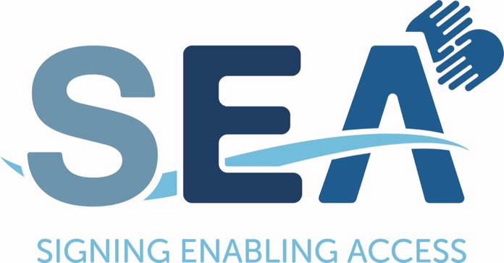

EQUAL OPPORTUNITIES MONITORING FORM

To help us monitor our equal opportunities in employment policy and the quality of service that we provide would you please complete this form. All answers will be kept anonymous.

Date Form Received:  (for office use only) | Application Number:  (for office use only)

PERSONAL DETAILS
Surname
First name
Date of Birth
Gender | Male Female
Is you gender identity from your birth sex? Yes No

ETHNIC GROUP | Tick one of the boxes below to choose your cultural background
- White British  - White Irish  - Other White Background  ………………………………………  - Black or Black British – Caribbean  - Black or Black British – African  - Other Black background  ……………………………………….  - Asian or Asian British – Indian  - Asian or Asian British – Pakistani  - Asian or Asian British – Bangladeshi  - Other Asian Background  ………………………………………. | - Mixed – White and Black Caribbean  - Mixed – White and Black African  - Mixed – White and Asian  - Other Mixed Background  ……………………………………………...  - Chinese  - Other Ethnic Background  ………………………………………………  Prefer not to say which
Nationality (if European other than British/Irish):

DISABILITY
The Disability Discrimination Act 1995 defines a person as having a disability if he/she has a Physical or Mental impairment which has a substantial and long-term adverse effect on his/her ability to carry out normal day-to-day activities.
Do you have a disability as defined above? Yes No

OTHERS
Please detail any other equal opportunities information that you would like to mention (e.g., sexual orientation, religion)

QUALITY OF SERVICE MONITORING
Where did you hear about us?

Newspaper Internet
Word of mouth Professional journal
Other (please specify)

How would you rate the service you have received so far?

Excellent Good Average Poor Not yet had any contact

Are you registered with any other recruitment agencies? Yes No

If yes, which ones?

